Annexure – 1

DIRECTORATE GENERAL OF SHIPPING, MUMBAI QUARTERLY TONNAGE STATEMENT - PERIOD: 3rd quarter – OCT 2024 to DEC 2024 Additions and Deletions of Indian-Flagged Vessels in Coastal Trade, Overseas Trade, and Indian Controlled Tonnage
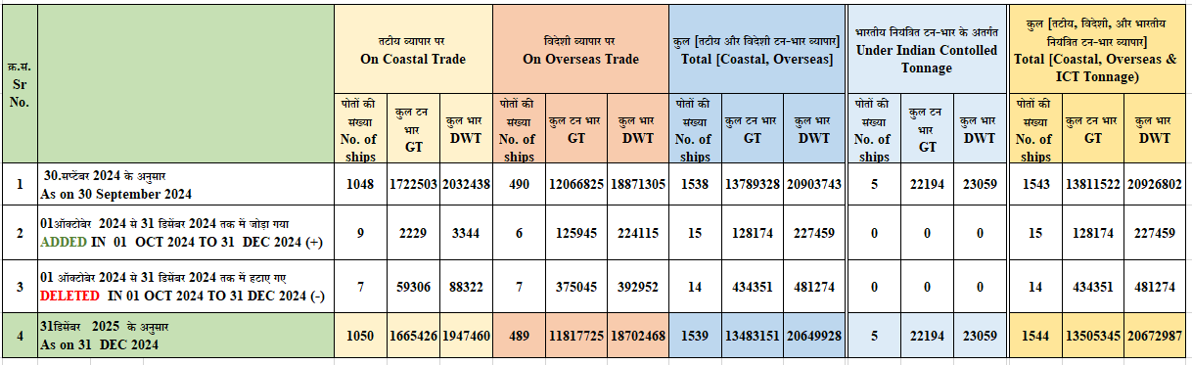
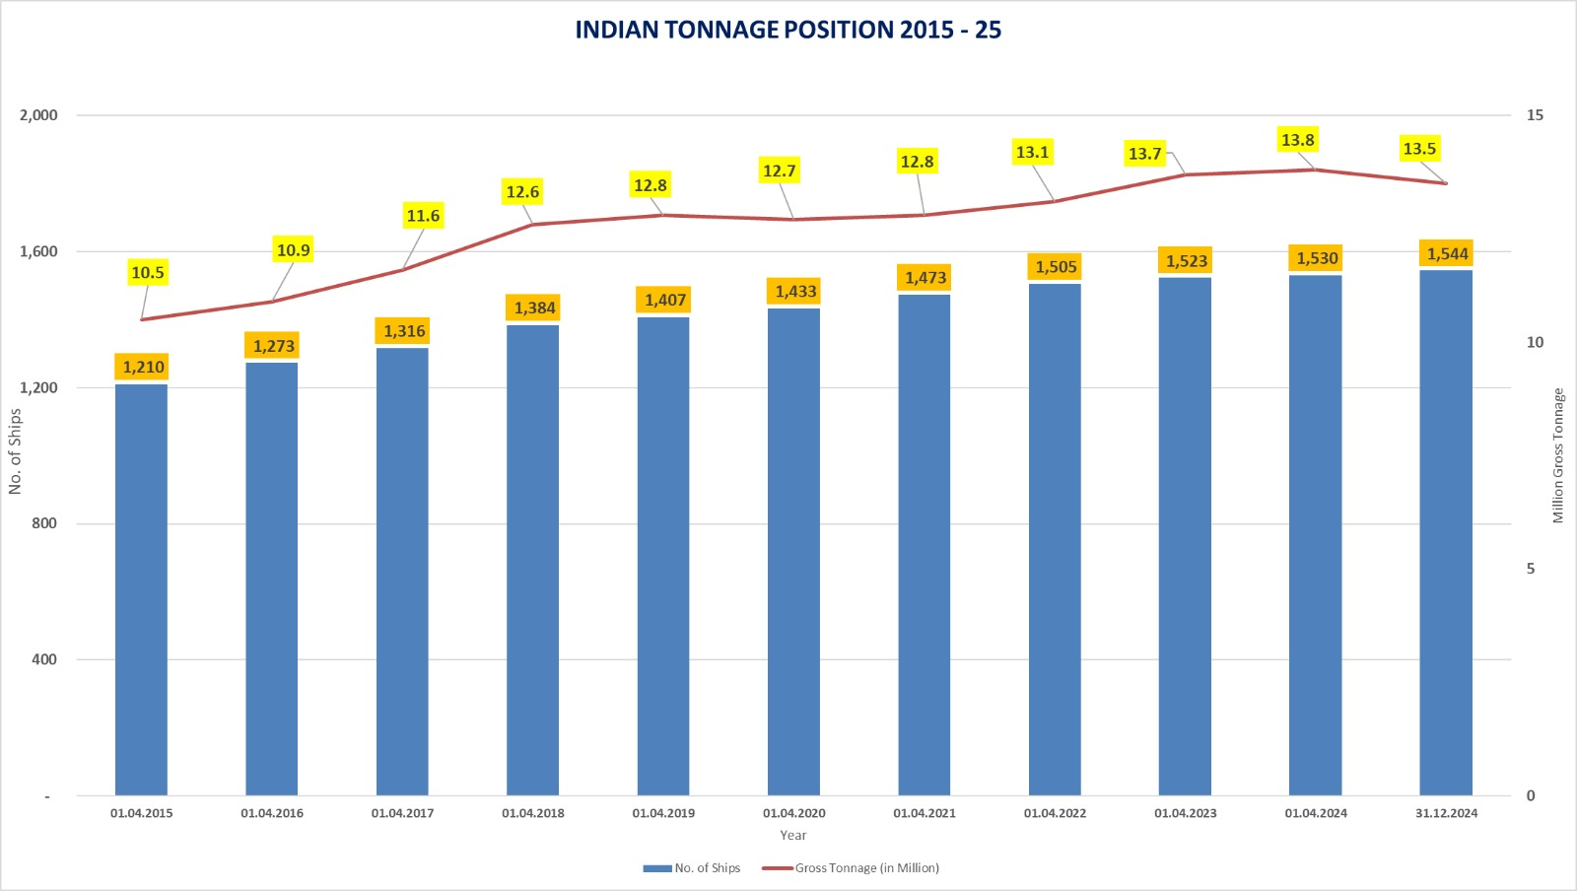

Annexure -2

Details of Additions and Deletions of Indian-Flagged Vessels in Coastal Trade, Overseas Trade, and Indian-Controlled Tonnage in the month of Oct 2024 to Dec 202
क्र.सं. Sr. No. | जलयान का नाम  Name of vessel(s) | जलयान का प्रकार  Type of Vessel | स्‍वामि का नाम  Name of Owner(s) | निर्मित वर्ष Year of build | कुल टनभार  GT | कुल भार  DWT
तटीय व्यापार पर जलयानों का जोड़ / Addition of Vessel on Coastal Trade
1 | Surya 9 | Tug | Kapsons Promoters Pvt Ltd | 2024 | 188 | 282
2 | Rudra 1 | Tug | Racon Marine Pvt Ltd | 2024 | 188 | 282
3 | KABIRA | Tug | Shoft Industries Pvt. Ltd. | 2024 | 347 | 520
4 | Limra | Tug | UNITED OCEAN MARINE SYSTEM | 2024 | 197 | 296
5 | Buraq 11 | Tug | Emerald Seaways | 2024 | 197 | 296
6 | Kabira 1 | Pleasure Craft | POONAM SANTOSH DARNE | 2024 | 13 | 20
7 | SONA VII | Steel Tug | Payda Venkata Rama, Lalit Ranjit & Padya Krishna Mohan | 2024 | 138 | 207
8 | VINKING | HSC Passenger Ship | BARGE Works Pvt Ltd | 2024 | 275 | 412
9 | ARCADIA MAHAVIR | Dumb barge | Habib Jahirshussain Bhadgad Salaya | 2024 | 686 | 1029
Total = 09 Vessels |  |  |  |  | 2,229 | 3,344
तटीय व्यापार पर जहाज का हटाना / Deletion of Vessel on Coastal Trade
1 | Sea Siddhee | Bulk Carrier | Segal Shipping Services Pvt. Ltd. | 2015 | 2052 | 2600
2 | Chola Harmony | Bulk Carrier | Treasure Harvest Shipping Pvt. Ltd. | 1999 | 38646 | 73941
3 | M.V. Nancowry | Passenger-Cum-Cargo vessel | Andaman & Nicobar Administration | 1991 | 14176 | 4963
4 | Rigel | Motor Launch | Marine Logis cs & Services Pvt Ltd | 2011 | 37 | 56
5 | Shiv Shambhu | General Cargo Ship | Shreeji Shipping (Gujarta) | 2022 | 1465 | 2254
6 | Bholenath | General Cargo Ship | Shreeji Shipping (Gujarta) | 2022 | 1465 | 2254
7 | Darya Sagar | General Cargo Barge Propelled | Shreeji Shipping (Gujarta) | 2022 | 1465 | 2254
Total =07 Vessels |  |  |  |  | 59,306 | 88,322
विदेशी व्यापार पर जलयानों का जोड़ / Addition of Vessel on Overseas Trade
1 | CHOLA SERENITY | Bulk Carrier | Treasure Harvest Shipping Pvt. Ltd. | 2005 | 39738 | 76596
2 | Jag Priyanka | Oil Tankers (Product Carrier) | GREAT EASTERN SHIPPING CO. LTD. | 2013 | 29708 | 49990
3 | Manna 25 | Offshore Supply Vessels | Manna Shipping & Logistics Pvt. Ltd. | 2010 | 2558 | 4477
4 | Sanmar Suparna | Steel/Oil Tanker | SSL Shipping Limited | 2024 | 40865 | 71990
5 | Orchid | Steel/Tanker/Double Hull | Seven Islands Shipping Ltd | 2024 | 8542 | 13127
6 | Seamec Anant | Steel/Diving Support Vessel | Hal offshore Limited | 2024 | 4534 | 7935
Total =0 6 Vessels |  |  |  |  | 1,25,945 | 2,24,115
विदेशी व्यापार पर जहाज का हटाना / Deletion of Vessel on Overseas Trade
1 | APJ Mahakali | Bulk Carrier | Apeejay Shipping Ltd. | 1996 | 36559 | 32279
2 | MT Jag Pranav | Oil Tanker (Crude Carrier) | Great Eastern Shipping Co. Ltd. | 2005 | 30095 | 51383
3 | M.V. Jag Rani | Bulk Carrier | Great Eastern Shipping Co. Ltd. | 2011 | 33036 | 56819
4 | MV Jag Lalit | Bulk Carrier | SEVEN ISLANDS SHIPPING LTD. | 2000 | 81396 | 45650
5 | Vasant 1 | Steel Longitudinally Framed Liquified Gas Carrier | Triumph Offshore Pvt Ltd | 2024 | 117514 | 97169
6 | Mareena Gas | LPG Carrier | Varun Gas Logis cs Pvt. Ltd. | 2001 | 47156 | 54826
7 | Loyalty | Oil Tankers  (Product Carrier) | Seven Islands Shipping Ltd. | 2000 | 29289 | 54826
Total =0 7 Vessels |  |  |  |  | 3,75,045 | 3,92,952
भारतीय नियंत्रित टन-भार के अंतर्गत जलयानों का जोड़
Addition of Vessel Under Indian Controlled Tonnage (ICT)
-- | -- | -- | -- | -- | -- | --
भारतीय नियंत्रित टन-भार के अंतर्गत जलयानों का हटाना
Deletion of Vessel Under Indian Controlled Tonnage (ICT)
-- | -- | -- | -- | -- | -- | --
जलयानों का ध्वज या नाम में बदलाव किए बिना बेचे गए जहाज / Vessels sold without changing the flag or name of the vessel
1 | Ocean Garnet | Supply Vessel | Urja Ships Pvt Ltd. | 2006 | 2072 | 2380
2 | M. V. Minicoy | Passenger Ship | Smt Zita Vijay, Properitor of M/s Anton Engineering, No. 591/1, TH Road, Old washermenpet, Chennai, India - 600021 | 2000 | 932 | 1398
3 | Vivek Prem | Dredgers | Ultra Dimensions Pvt Ltd. | 1997 | 1316 | 1974

