Annexure - 1

DIRECTORATE GENERAL OF SHIPPING, MUMBAI
QUARTERLY TONNAGE STATEMENT–PERIOD: 4th quarter – JAN 2025 to MARCH 2025 Additions and Deletions of Indian-Flagged Vessels in Coastal Trade, Overseas Trade, and Indian-Controlled Tonnage
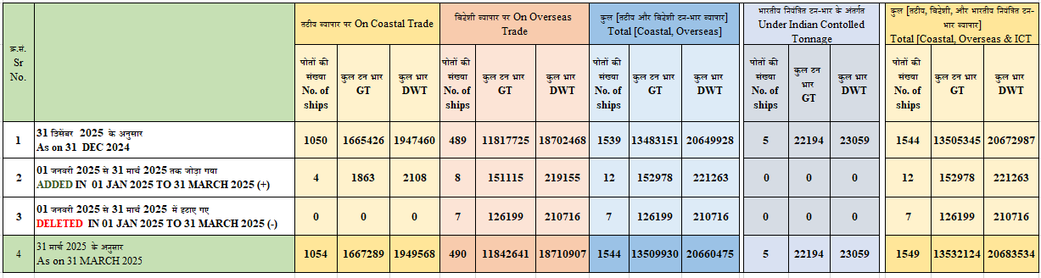
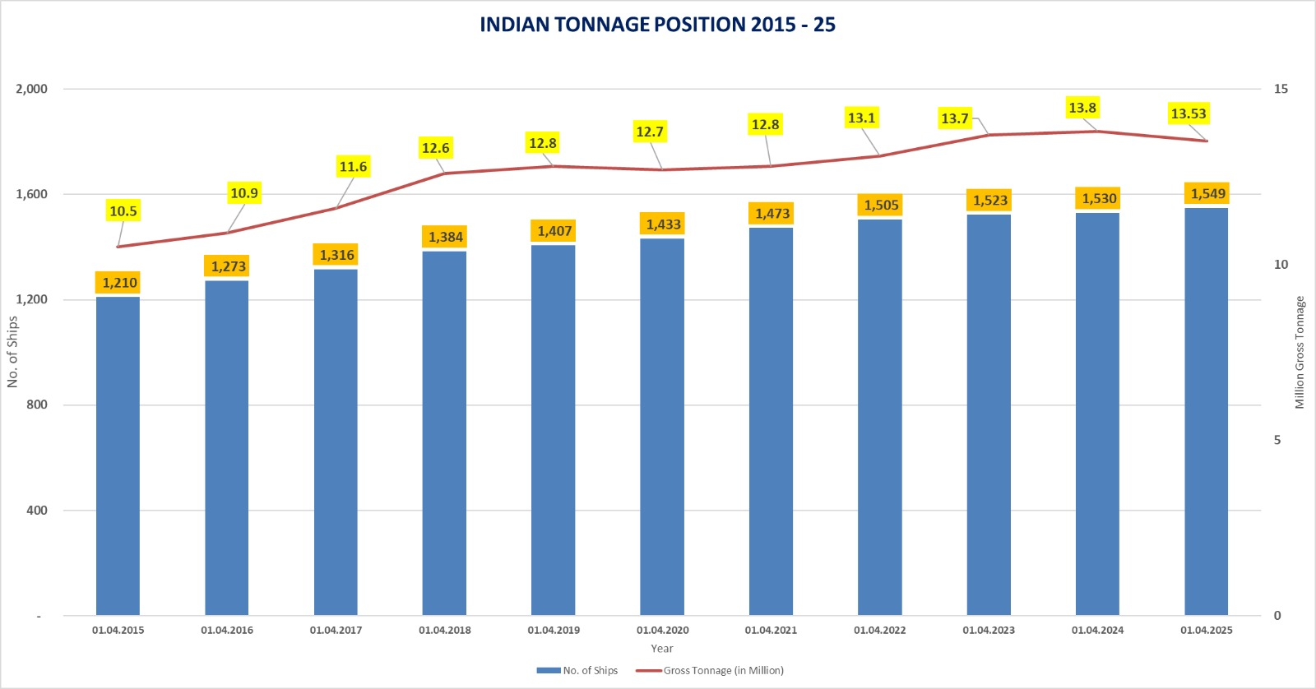

Annexure - 2
Details of Additions and Deletions of Indian-Flagged Vessels in Coastal Trade, Overseas Trade, and Indian- Controlled Tonnage in the month of 01.01.2025 to 31.03.2025
क्र .सं.  Sr. No | जलयान का नाम  Name of vessel(s) | जलयान का प्रकार  Type of Vessel | स्वामि का नाम  Name of Owner(s) | निर्मित वर्ष Year of  build | कुल टनभार  GT | कुल भार  DWT
तटीय व्यापार पर पोत का जोड़ / Addition of Vessel on Coastal Trade
1 | SONALIKA | Tug | Ozeevo Shipping Ifsc  Private Limited | 2005 & South Korea | 190 | 285
3 | SAROVAR | Tug | Sheik Ahmed Alisha & Shaik Haseena Begum, Gujarat | 2025 Kakinada India | 365 | 548
7 | AJR WB I | OSV | Bapu’s Shipping Pvt Ltd, Jamnagar | 2007 | 1120 | 993
4 | SHIPRA I | Tug | Racon Marine Private Limited | 2025 | 188 | 282
Total = 04 vessels |  |  |  |  | 1,863 | 2,108
तटीय व्यापार पर जहाज का हटाना / Deletion of Vessel on Coastal Trade

- | - | - | - | - | - | -
Total = 0 vessels |  |  |  |  | 0 | 0
विदेशी व्यापार पर पोत का जोड़ / Addition of Vessel on Overseas Trade
1 | SEAMEC ANANT | Motor | Hal Offshore Limited | 2023 Ratnagiri | 4815 | 8527
2 | DYNASTY | STEEL/OIL TANKER | SEVEN ISLANDS SHIPPING LTD | 1999/S.KOREA | 28246 | 46231
2 | CANGJIE | Oil Tanker | Ozeevo Shipping Ifsc Private Limited | 2005 & South Korea | 59248 | 98184
4 | COASTAL ANUGRA II | Mildsteel/Tug | Coastal Marine Construction & Engg Ltd | 2025 India | 483 | 525
5 | M2M PRINCESS | Aluminum HSC | M2m Ferries Pvt Ltd | 2003 Italy | 2252 | 3945
6 | JAL KAMDHENU | Steel/Bulk Carrier | Jal Kukud Shipping Hsc Pvt Ltd | 2020 Japan | 45246 | 53181
7 | VIKING SPIRIT | Hsc Passenger  Ship | Barge Works Private Ltd | 2008 & Malaysia | 275 | 110
8 | FORTUNE | STEEL OIL CARRIER | SEVEN ISLANDS SHIPPING LTD | 2008/BUSAN KOREA | 8550 | 8552
Total = 08 vessels |  |  |  |  | 1,51,115 | 2,19,155
विदेशी व्यापार पर जहाज का हटाना / Deletion of Vessel on Overseas Trade
1 | NAVDHENU PURNA | Steel/Bulk Carrier | Arcadia Shipping Limited | 2001 China | 29961 | 44942
2 | FOG 19 | Steel/Offshore Supply Vessel | First Oil and Gas Pvt | 2014 China | 2568 | 3852
3 | FOG 15 | Steel/Offshore Supply Vessel | First Oil and Gas Pvt | 2009 China | 2456 | 4246
4 | CHANDRA JUPITER | Offshore Support Vessel | Arc Offshore India Pvt Ltd, Kakinada | 2014 China | 1163 | 930
5 | JAG PADMA | Steel/Oil Tanker | The Great Eastern Shippin Co Ltd | 2005 Japan | 28799 | 50399
6 | JAG RASHI | Steel/Oil Tanker | The Great Eastern Shippin Co Ltd | 2011 China | 33036 | 57813
7 | DYNASTY | STEEL/OIL TANKER | SEVEN ISLANDS SHIPPING LTD | 1999/S.Korea | 28216 | 48534
Total = 07 vessels |  |  |  |  | 1,26,199 | 2,10,716
भारतीय नयं त टन-भार के अंतगत जलयान का जोड़/ Addition of Vessel Under Indian Controlled Tonnage (ICT)
- | - | - | - | - | - | -
भारतीय नयं त टन-भार के अंतगत जलयान का हटाना/ Deletion of Vessel Under Indian Controlled Tonnage (ICT)
- | - | - | - | - | - | -
जलयान का वज या नाम म बदलाव कए बना बेचे गए जहाज / Vessels sold without changing the flag or name of the vessel
1 | OCEAN DIAMOND | Steel/Platform Supply Vessel | Alphard ventures Pvt Ltd | 2007 China | 2443 | 3665
2 | VARAIII | Steel/Tug | Dhruvin Manish Shah  Bipin Kumar Singh | 1995 Cochin | 374 | 561
3 | ACOMS II | Steel/Tug Utility Vessel | Geoservices Maritime Pvt | 1998 Alabama USA | 353 | 530
4 | NEERA | Steel/Tug | Yaswant Kumar Singhee  Basant Kumar Singhee  Mukesh Singhee | 2019 Bedi Jamnagar | 127 | 191
5 | ALBATROSS 19 | Steel/Tug | Mr Yusuf Mohamed Saleel | 1982 Singapore | 317 | 476
6 | ANGRIYA | Steel/RSPV Type 4 | LMCS maritime Pvt Ltd | 1997 Japan | 6865 | 12014
7 | THERA | Steel/Achore Handling Tug Supply Vessel | Mark Marine Services Pvt Ltd | 2006 China | 2014 | 3527
8 | GAYATHRI | Motor Tender | Saral Logistics Solutions, Navi Mumbai | 2015 Kakinada | 91 | 137
9 | ASHWINI | Steel/Tug | Kabir Rajesh Kewalramani | 2006 Chennai | 149 | 224
10 | DOLPHIN NO. 1 | Steel/Coastal Tug | Adya Prasad Mishra | 1996 Korea | 94 | 141

