Annexure – 1

DIRECTORATE GENERAL OF SHIPPING, MUMBAI QUARTERLY TONNAGE STATEMENT - PERIOD: 1st quarter – APRIL 2025 to JUNE 2025 Additions and Deletions of Indian-Flagged Vessels in Coastal Trade, Overseas Trade, and Indian-Controlled Tonnage
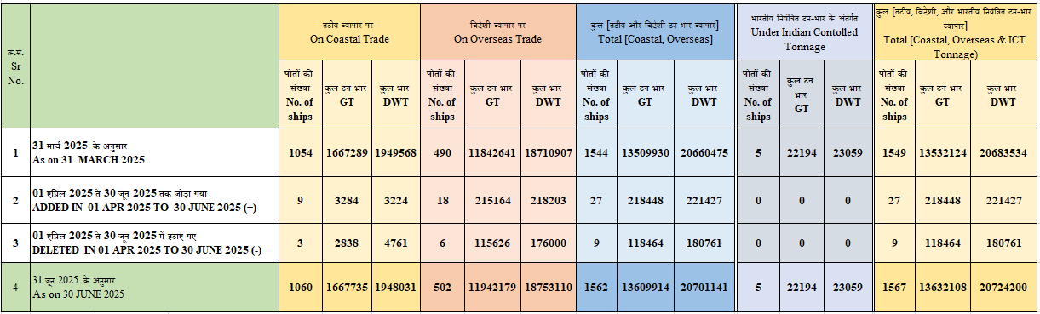

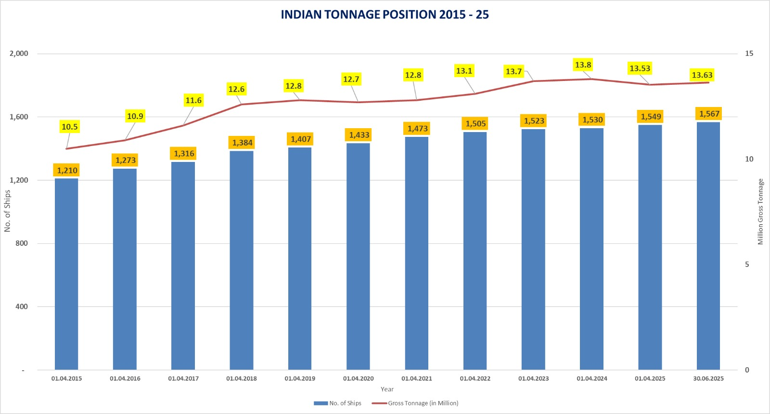

Annexure - 2

Details of Additions and Deletions of Indian-Flagged Vessels in Coastal Trade, Overseas Trade, and
Indian- Controlled Tonnage in the month of 01.04.2025 to 30.06.2025
क्रम संख्या Sr. No. | जलयान का नाम  Name of vessel(s) | जलयान का प्रकार  Type of Vessel |  | स्वामि का नाम  Name of Owner(s) | निर्माण का वर्ष  Year of build | कुल टनभार  GT | कुल भार  DWT
तटीय व्यापार में जलयान को शामिल करना / Addition of Vessel on Coastal Trade
1 | TITAN 12 | Tug |  | Eastern Navigation Pvt Ltd | - | 104 | 156
2 | SARYU 3 | Pilot Lauch |  | Eastern Navigation Pvt Ltd | - | 68 | 102
3 | SHIV SAGAR | General Cargo Barge |  | M/S Shree Sagar Stevedores Pvt Ltd | 2025 | 1380 | 1022
4 | SAN 500 | OIL TANKER (RSV) |  | M/S.Savannah Offshore Logistics Pvt.Ltd | 2025 | 411 | 617
5 | KB 49 | Tug |  | 1.Vijay Kantilal Sanghavi  2. Shailesh Mansukhlal Mehta  Partner's Of M/S K.B Shipping  And Company Bardanwala | 2024 | 108 | 162
6 | MARATHA MAYNAK | Steel/Tug |  | Chowgule Lavgan Shiprepair Pvt Ltd | 2009 | 426 | 639
7 | SHALIMAR | TUG |  | Savannath Offshore Logistics Pvt Ltd | 2005 Kakinada | 366 | 263
8 | SAMURAI | TUG |  | Sheik Ahmed Alisha  Sheik Haseena beguam | 2005 Kakinada | 366 | 263
9 | ABS REVATI | Steel Petrol Boat (RSV 1) |  | ABS Marine Services Limited | 2025 | 55 | 83
Total = 09 Vessels |  |  |  |  |  | 3,284 | 3,224
तटीय व्यापार पर जलयान का हटाना / Deletion Of Vessel On Coastal Trade
1 | SAN GALAXY | Tug |  | Thriloka M, Proprietor Of M/S.Amit Fission Service & Solutions. | 2022 | 178 | 267
2 | SURYA 1 | Mini Bulk Carrier |  | Svs Marine Services Private Limited | 2010 | 1330 | 2247
3 | SURYA 2 | Mini Bulk Carrier |  | Svs Marine Services Private Limited | 2010 | 1330 | 2247
Total = 03 Vessels |  |  |  |  |  | 2,838 | 4,761
विदेशी व्यापार में जलयान को शामिल करना / Addition Of Vessel On Overseas Trade
1 | GREEN SANVI | Steel/Lpg Carrier |  | Mol Shipping IFSC Pvt Ltd | 2009 | 47005 | 58811
2 | CANGJIE | Oil Tanker |  | M/S.Ozeevo Shipping IFSC Private Ltd | 2005 | 57248 | 10984
3 | JAL GARUDA | Steel/Chemical Oil Tanker |  | Jal Kumud Shipping IFSC Pvt Ltd | 2000 | 16786 | 26612
4 | VOLVOX OLYMPIA | Steel/Hopper Dredger |  | Van Oord India Pvt.Ltd | 2003 | 4967 | 6355
5 | CMA CGM VITORIA | Steel/Container Ship |  | Cma Cgm Shipping India IFSC Pvt.Ltd | 2008 | 26836 | 33434
6 | PEBBLES | Steel/Oil/Chemical Tanker |  | Seven Islands Shipping Ltd | 2008 | 8689 | 13153
7 | SEAGAUTAM AARNAV | Steel/Generak Cargo Vessel |  | Seagautam Shipping Pvt.Ltd | 2025 | 2853 | 2094
8 | CMA CGM MANAUS | Steel/Container Ship |  | Cma Cgm Shipping Assets India IFSC Private Limited | 2009 | 26836 | 33413
9 | AKSHIP 1 | Steel/Supply Vessel |  | Vedant Ship Management (India) Private Limited | 2008 | 1678 | 1364
10 | AMNS HERCULES | Steel/Dredger |  | Arcelor Mittal Nippon Steel  India Ltd Gujarat | 2015 | 13551 | 18514
11 | KSR SHABARI | Oil Tanker |  | M/S Avatar Petrochemica Ls Private Limited | 2025 | 202 | 303
12 | CANARA MEGH | Mild Steel/Tug |  | Can Offshore Pvt Ltd.Mumbai | 2025 | 292 | 438
13 | MARATHA TANAJI | Steel/Tug |  | Chowgule Lavgan Shiprepair Pvt.Ltd | 2009 | 426 | 639
14 | DARYA SAGAR | Motor Ship |  | M/S. Shreeji Shipping Global Pvt.Ltd | 2022 | 1465 | 2254
15 | BHOLENATH | Motor Ship |  | M/S.Shreeji Shipping Global Pvt Ltd | 2020 | 1465 | 2254
16 | SHIV SHAMBHU | Motor Ship |  | M/S.Shreeji Shipping Global Pvt Ltd | 2022 | 1465 | 2254
17 | A.E.L II | Motor Ship |  | M/S.Adani Bunkering Pvt.Ltd | 2010 | 2095 | 3116
18 | VARAHA | Motor Ship |  | M/S Shreeji Shipping Global Pvt Ltd | 2025 | 1305 | 2211
Total = 18 Vessels |  |  |  |  |  | 2,15,164 | 2,18,203
विदेशी व्यापार पर जलयान का हटाना / Deletion Of Vessel On Overseas Trade
1 | NAVDHENU SUN | Steel/Bulk Carrier | Arcadia Shipping Ltd |  | 2001 | 27198 | 48910
2 | SUDARSHAN | Steel/Offshore Support Vessel | Lilly Maritime Pvt.Ltd |  | 1991 | 2411 | 3617
3 | APJ KAIS | Bulk Carrier | Apeejay Shipping Ltd, Apeejay House Kolkata |  | 2009 | 32957 | 57675
4 | NEW CEDAR | Steel/Gas Carrier | BW Global United India Pvt Ltd |  | 2007 Ulsan Korea | 47386 | 58173
5 | HOPE SEVEN | Container Cum General Cargo Ship | M/S.Hansa Shipping & Logistics Pvt.Ltd |  | 2014 | 1335 | 2337
6 | OCEAN TURQUOISE | Steel/Offshore  Supply Vessel | Samson Maritime Ltd Mumbai |  | 2014 | 4339 | 5288
Total = 06 Vessels |  |  |  |  |  | 1,15,626 | 1,76,000
भारतीय नियंत्रित टन भार के तहत पोत को शामिल करना / Addition of Vessel Under Indian Controlled Tonnage (ICT)
- | - | - | - |  | - | - | -
भारतीय नियंत्रित टन भार के तहत पोत को हटाना / Deletion of Vessel Under Indian Controlled Tonnage (ICT)
- | - | - | - |  | - | - | -
बीबीसीडी की मंजूरी पर हासिल किए गए जहाज / Vessels acquired on an approval of a BBCD [Bare Boat Charter & Demise] proposal
-- | -- | -- | -- |  | -- | -- | --
जहाज का झंडा या नाम बदले बिना बेचे गए जहाज / Vessels sold without changing the flag or name of the vessel
1 | AQUATOR-1 | Steel/Crew Boat | Eastern Navigator Pvt.Ltd. |  | 2015 | 94 | 141
2 | CHENNAI VALARCHI | Steel /Bulk carrier | Searete India IFSC Pvt. Ltd. |  | 2004 | 38845 | 67979
3 | EMRALD | OSV | ABS Marine Services Ltd. |  | 2008 | 2443 | 4276

