Annexure - 1

DIRECTORATE GENERAL OF SHIPPING, MUMBAI
QUARTERLY TONNAGE STATEMENT - PERIOD: 2nd quarter – JULY 2025 to SEP 2025 Additions and Deletions of Indian-Flagged Vessels in Coastal Trade, Overseas Trade, and Indian-Controlled Tonnage

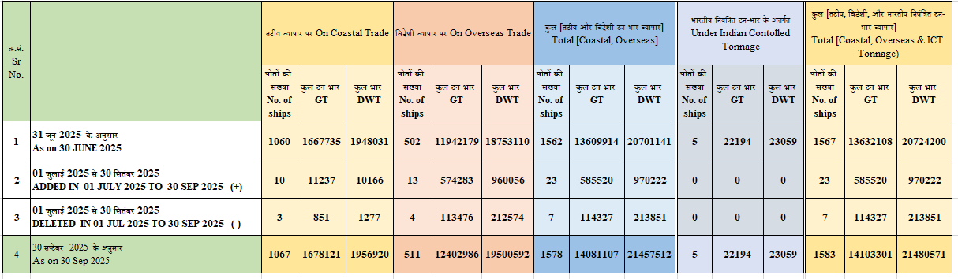

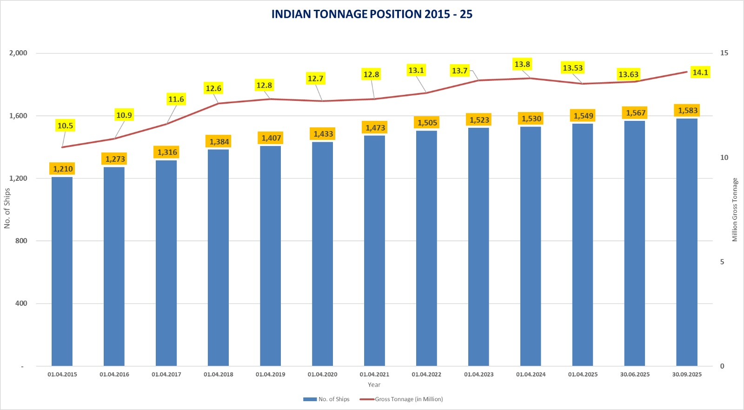

Annexure - 2
Details of Additions and Deletions of Indian-Flagged Vessels in Coastal Trade, Overseas Trade, and Indian- Controlled
Tonnage in the month of 01.07.2025 to 30.09.2025

क्र .सं.  Sr. No | जलयान का नाम  Name of vessel(s) | जलयान का प्रकार  Type of Vessel | स्वामि का नाम  Name of Owner(s) | निर्मित वर्ष Year of build | कुल टनभार  GT | कुल भार  DWT
तटीय व्यापार पर पोत का जोड़ / Addition of Vessel on Coastal Trade
1 | SIDDHIVINAYAK III | General Cargo Barge | M/s. JAYDEEP ASSOCIATE PVT LTD, GUJARAT | 2025 | 1306 | 2179
2 | ATI ONGC GOA | Dumb Pontoon | M/s. OIL & NATURAL GAS CORPORATION LTD | 2025 | 200 | 300
3 | APCO BRAHMAPUTRA 3 | Mild Steel/Tug | APCO INFRATECH PRIVATE LIMITED | 2025/ KARNATAKA | 132 | 198
4 | OFFSHORE UNITY | Steel/Offshore Support Vessal | RAJ SHIPPING AGENCIES LIMITED | 2009/ BATAM INDONESIA | 1815 | 1769
5 | SEA STALLION-1 | Aluminium/Hsc Passenger Ship | SHM SHIPCARE PRIVATE LIMITED | 2021/ INDONESIA | 332 | 149
6 | RELTUG TWENTY | Steel Welded Transverse/Tug | RELIANCE INDUSTRIES LIMITED | 2025/DAHEJ GUJARAT | 250 | 375
7 | MAHANADI | Steel/Tug/Supply Vessel | GLOBAL OFFSHORE SERVICES LIMITED | 2006/SINGAPORE | 1823 | 2204
8 | AQUA TOW | Steel/Tug | GLOBAL CAMBAY MARINE SERVICES PRIVATE LIMITED | 2010/MALAYSIA | 476 | 292
9 | SEA PRESTIGE | Steel/Anchor Handling Supply Vessel | HIND OFFSHORE PRIVATE LIMITED MUMBAI | 2007/CHINA | 1966 | 1500
10 | SEAQUEST GARUDA | Steel/Offshore Support Vessel | SARAF CORPORATION INDIA PRIVATE LIMITED | 2014/CHINA | 2937 | 1200
Total 10 Vessel |  |  |  |  | 11,237 | 10,166
तटीय व्यापार पर जहाज का हटाना / Deletion of Vessel on Coastal Trade
1 | ESSAR TUG VII | Steel/Pusher Tug | Equiptrans Logistics Private Limited | 1996/SURAT | 326 | 489
2 | ESSAR TUG XI | Steel/Pusher Tug | Equiptrans Logistics Private Limited | 1996/SURAR | 326 | 489
3 | PARASEA TWO | Steel/Tug | Paradigm Marine & Technical Services Private Limited | 1997/CHINA | 199 | 299
Total 03 vessel |  |  |  |  | 851 | 1,277
विदेशी व्यापार पर जलयानɉ का जोड़ / Addition of Vessel on Overseas Trade
1 | RIPLEY PINNACLE | BULK CARRIER | RIPLEY PINNACLE INDIA IFSC PRIVATE LIMITED | 2004 JAPAN | 40060 | 76838
2 | CHOLA LEGACY | BULK CARRIER | M/S. TREASURE HARVEST SHIPPING PRIVATE LIMITED, CHENNAI | 2007 | 43158 | 82535
3 | BW CHINOOK | GAS CARRIER | BW GLOBAL UNITED LPG INDIA PVT LTD, METTUKUPPAM CHENNAI | 2015 & SHANGHAI, CHINA | 46789 | 53660
4 | PROSPER | STEEL/CHEMICAL OIL TANKER | SEVEN ISLANDS SHIPPING LIMITED MUMBAI | 2008/SOUTH KOREA | 8545 | 13148
5 | GREEN SACHI | STEEL/LIQUIFIED GAS CARRIER | MOL SHIPPING IFSC PRIVATE LIMITED | 2010/ULSAN KOREA | 47005 | 58811
6 | GREEN SHAKTI | STEEL/ LIQUIFIED GAS CARRIER | MOL SHIPPING IFSC PRIVATE LIMITED | 2010/SOUTH KOREA | 47005 | 58811
7 | SANMAR SHEHNAI | STEEL/OIL TANKER | SSL SHIPPING LIMITED | 2008/JAPAN | 26911 | 47165
8 | SANMAR HERALD | STEEL/OIL TANKER | SSL SHIPPING LIMITED TAMIL NADU | 2007/SOUTH KOREA | 159027 | 309000
9 | GATEWAY | STEEL/OIL TANKER | SEVEN ISLANDS SHIPPING LIMITED MUMBAI | 2012/JAPAN | 28736 | 45950
10 | APJ PRIYA 2 | BULK CARRIER | APEEJAY SHIPPING LTD | 20.12.2006, JAPAN | 43189 | 82298
11 | APJ PRITI 2 | BULK CARRIER | APEEJAY SHIPPING LTD | 2006 JAPAN | 43168 | 82574
12 | CMA CGM DIAMOND | STEEL/CONTAINER | CMA CGM SHIPPING ASSETS INDIA IFSC PRIVATE LIMITED | 2008 CHINA | 36007 | 42000
13 | SEAGAUTAM | STEEL/GENERAL CARGO | SEAGAUTAM SHIPPING PRIVATE LIMITED | 2019 ZHEJIANG | 4683 | 7266
Total 13 Vessel |  |  |  |  | 5,74,283 | 9,60,056

विदेशी व्यापार पर जहाज का हटाना / Deletion of Vessel on Overseas Trade
1 | ARK PROGRESS | OIL/CHEMICAL TANKER | HAMSA SHIP PVT LTD | 1995/2007© JAPAN/ARGENTINA © | 4236 | 7355
2 | SAFE CAT | STEEL/CATEMARAN | MR.YASHDEEPSINH M. GOHIL &  MR.MAHENDRASINH K. GOHIL C/O. MAYA  MARINE & LOGISTICS GUJARAT | 2000 | 195 | 293
3 | CONCORD | STEEL/CRUDE OIL TANKER | SEVEN ISLANDS SHIPPING LIMITED MUMBAI | 2005/KOREA | 81076 | 159156
4 | REGENCY | STEEL/OIL TANKER | SEVEN ISLANDS SHIPPING LIMITED MUMBAI | 2002/JAPAN | 27969 | 45770
Total 04 Vessel |  |  |  |  | 1,13,476 | 2,12,574
भारतीय नयं त टन-भार के अंतगत जलयान का जोड़/ Addition of Vessel Under Indian Controlled Tonnage (ICT)
- | - | - | - | - | - | -
भारतीय नयं त टन-भार के अंतगत जलयान का हटाना/ Deletion of Vessel Under Indian Controlled Tonnage (ICT)
- | - | - | - | - | - | -
जलयान का वज या नाम म बदलाव कए बना बेचे गए जहाज / Vessels sold without changing the flag or name of the vessel
1 | SAN PRINCES | TUG | M/S.P3 INDIAN OCEAN SHIPPING AND TRADING (OPC) PRIVATE LIMITED | NOVEMBER 2022 & KAKINADA | 141 | 212
2 | SANRISE-I | STEEL, UTILITY VESSEL | M/S.CAN OFFSHORE PRIVATE LIMITED | 2012 | 65 | 98
3 | SEASTAR AMBA ONE | STEEL/TUG | KRISH SHIP MANAGEMENT PRIVATE LIMITED MUMBAI | 2003/MALAYSIA | 193 | 290
4 | DOLPHIN NO 2 | STEEL/TUG | OCEAN SPARKLE LIMITED | 2010/JAPAN | 372 | 558
5 | DOLPHIN NO 30 | STEEL/TUG | OCEAN SPARKLE LIMITED | 2020/JAPAN | 495 | 743
6 | DOLPHIN NO 25 | STEEL/TUG | OCEAN SPARKLE LIMITED | 2016/JAPAN | 467 | 701
7 | SHIVALI II | STEEL/TUG | 1.BIPIN KUMAR SINGH  2. ANIL KUMAR  3.DHRUVIN MANISH SHAH | 1997/CHINA | 247 | 371
8 | SHIVALI | STEEL/TUG | 1.SWATI DHARMENDRA JHA-(05) SHARES  2. ABHISHEK DHARMENDRA JHA-(05) SHARES | 2001/INDIAN | 214 | 321

