Annexure - 1
DIRECTORATE GENERAL OF SHIPPING, MUMBAI
QUARTERLY TONNAGE STATEMENT - PERIOD: 3rd quarter – OCT 2025 to DEC 2025 Additions and Deletions of Indian-Flagged Vessels in Coastal Trade, Overseas Trade, and Indian Controlled Tonnage
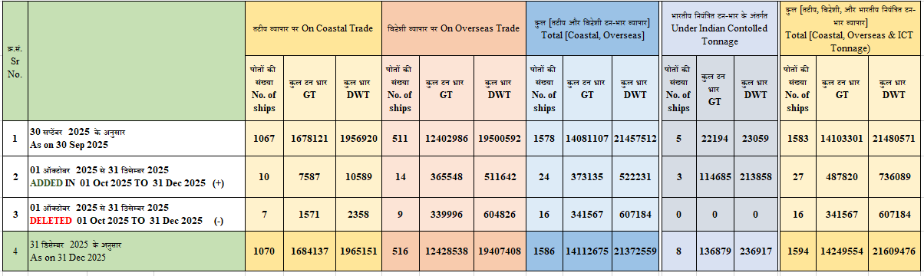
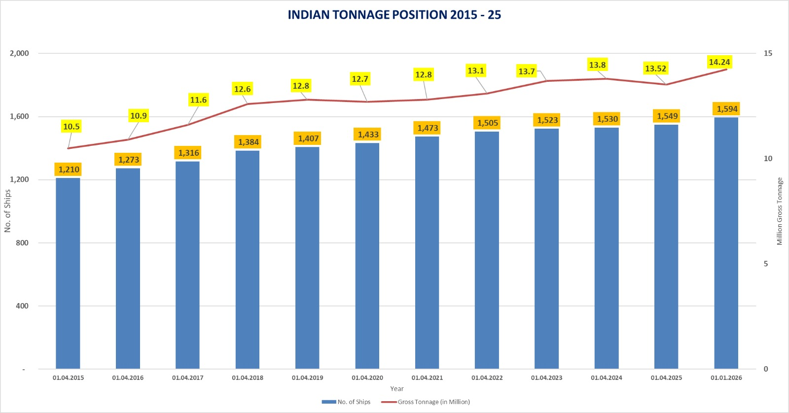

Annexure - 2
Details of Additions and Deletions of Indian-Flagged Vessels in Coastal Trade, Overseas Trade, and Indian- Controlled Tonnage in the month of 01.10.2025 to 31.12.2025
क्र .सं.  Sr. No | जलयान का नाम  Name of vessel(s) | जलयान का प्रकार  Type of Vessel | स्वामि का नाम  Name of Owner(s) | निर्मित वर्ष Year of  build | कुल टनभार  GT | कुल भार  DWT
तटीय व्यापार पर पोत का जोड़ / Addition of Vessel on Coastal Trade
1 | KABIRA 1 | OBM | Sealink Adventures India Pvt.Ltd | 2025 | 480 | 720
2 | SANVI 69 | Oil Tanker | M/S. Maritime Nexus Shipping Private Limited | 2015 | 2117 | 3034
3 | OSL GANJAM | Tug | Orissa Stevedores Limited. | 2010 Japan | 376 | 564
4 | MAT LYRA | Multi Utility Tug | M/S. Mat Marine Services Private Limited | 2025 Kakinada India | 220 | 330
5 | OCEAN CREWZER-VI | Aluminium/ Crew Boat | SHM Shipcare Private Limited Mumbai | 2025 | 169 | 254
6 | SIDDHIVINAYAK V | General Cargo Ship | M/S. Jaydeep Associate Pvt. Ltd Gujarat | 2025 | 1311 | 1967
7 | OCEAN ALLIANCE | Tug | Ocean Sparkle Limited Gujarat | 2025 Udupi Karnataka | 498 | 237
8 | APCO BRAHMAPUTRA 4 | Tug | Apco Infratech Private Limited Uttar Pradesh | 2025  Karnataka | 133 | 200
9 | SANVI 69 | Oil Tanker | M/S. Maritime Nexus Shipping Private Limited | 2015 | 2117 | 3034
10 | VMS SKY | Aluminium/  Hsc Crew Boat | Vinayak Marine Services Private Limited Mumbai | 2025/India | 166 | 249
Total = 10 vessels |  |  |  |  | 7,587 | 10,589
तटीय व्यापार पर जहाज का हटाना / Deletion of Vessel on Coastal Trade
1 | JALA HAMSA | Tug | M/S.Kakinada Seaports Ltd Hyderabad | 1996 | 265 | 398
2 | JALA KANYA | Tug | M/S.Kakinada Seaports Ltd Hyderabad | 1997 | 265 | 398
3 | JALA TARANGINI | Tug | M/S.Kakinada Seaports Ltd Hyderabad | 1997 | 265 | 398
4 | ESSAR TUG X | Steel /Welded /Pusher Tug | Equiptrans Logistics Private Limited Gujrat | 1996/Surat | 336 | 504
5 | LILY | Tug | Andamax India Private Limited | 2008/The Netherlands | 140 | 210
6 | RELTUG ONE | Tug | Reliance Industries Limited Mumbai | 1992/  Ratnagiri | 150 | 225
7 | RELTUG TWO | Tug | Reliance Industries Limited Mumbai | 1992/  Ratnagiri | 150 | 225
Total = 07 vessels |  |  |  |  | 1,571 | 2,358
विदेशी व्यापार पर पोत का जोड़ / Addition of Vessel on Overseas Trade
1 | COMPASS | Steel/Oil Tanker | Seven Islands Shipping Limited Mumbai | 2009/South Korea | 81306 | 157985
2 | SHIVANSHI POOJA | Steel/Oil Tanker | Shivansh Offshore and Marine Services Private Limited | 2008/China | 3220 | 4641
3 | HARIGYAN | Steel/Oil /Chemical Tanker | Castle Ships Private Limited Mumbai | 2008/South Korea | 29305 | 4999
4 | SANMAR SWARA | Oil Tanker | SSL Shipping Limited Tamil Nadu | 2006 | 40803 | 74993
5 | MAERSK VIGO | Container Ship | Maersk Bharat IFSC Pvt Ltd | 2010 | 18326 | 23338
6 | MAERSK VILNIUS | Container Ship | Maersk Bharat IFSC Pvt Ltd | 2010 | 20927 | 29145
7 | MARIA GLORY | Chemical/Oil Tanker | Maria Shipping Private Limited | 2006 | 29348 | 46616
8 | CMA CGM MENDELSSOHN | Container Ship | CMA CGM Shipping Assets India IFSC Private Limited | 2012 | 38364 | 46956
9 | SJ LILLY | General Cargo | Shreeji Global Ifsc Pvt Ltd | 2025 | 5998 | 9506
10 | SAHYADRI | Liquefied Gas Carrier | The Shipping Corporation of India Limited Mumbai | 2009 Ulsan Korea | 47058 | 54526
11 | SHIVALIK | Liquefied Gas Carrier | The Shipping Corporation of India Limited Mumbai | 2009 Ulsan Korea | 47058 | 54534
12 | MDPL 4 | General Cargo Barge | Majestic Marine Charters Pvt Ltd Goa | 2025 | 1470 | 2195
13 | SIDDHIVINAYAK IV | General Cargo Barge | Jaydeep Associates Pvt Ltd Gujarat | 2025 | 1313 | 630
14 | BAYWAY I | Oil Tanker | Majestic Marine Charters Pvt Ltd Goa | 2025 | 1052 | 1578
Total = 14 vessels |  |  |  |  | 3,65,548 | 5,11,642
विदेशी व्यापार पर जहाज का हटाना / Deletion of Vessel on Overseas Trade
1 | SANMAR SONNET | Oil Tanker | Sanmar Shipping Limited Chennai | 1997/Japan | 56854 | 99999
2 | INTERSEA VOYAGER | Bulk Carrier | Intersea Maritime Limited Chennai | 2001/Japan | 38888 | 74117
3 | JAG PRIYA | Oil Tanker | The Great Eastern Shipping Company Limited | 2010/Japan | 28465 | 49999
4 | INDIRA GANDHI | Cargo Container Carrier | The Shipping Corporation of India Limited | 1993/Korea | 21963 | 28880
5 | LAL BAHADURSHASTRI | Cargo | The Shipping Corporation of India Limited | 1993/Korea | 21963 | 28880
6 | NAV DURGA | Oil Tanker | Nav Bharat Tankers Private Limited Mumbai | 2003/Ulsan Korea | 23265 | 39634
7 | CENTURY | Crude Oil Tanker | Seven Islands Shipping Limited Mumbai | 2005/Korea | 81076 | 159186
8 | MAHA JACQUELINE | Bulk Carrier | B.G. Shirke Construction Technology Private  Limited Pune | 1999/Japan | 38667 | 75592
9 | JAG POOJA | Oil Tanker | The Great Eastern Shipping Co. Ltd Mumbai | 2005/Japan | 28855 | 48539
Total = 09 vessel |  |  |  |  | 3,39,996 | 6,04,826
भारतीय नयं त टन-भार के अंतगत जलयान का जोड़/ Addition of Vessel Under Indian Controlled Tonnage (ICT)
1 | JAG ANJALI | Oil Tanker | The Great Eastern Shipping Co. Ltd Mumbai | 2010 | 43036 | 81922
2 | JAG PRIYA | Bulk Carrier | The Great Eastern Shipping Co. Ltd Mumbai | 2015 | 28465 | 81843
3 | JAG AMOL | Bulk Carrier | The Great Eastern Shipping Co. Ltd Mumbai | 2016 | 43184 | 50093
Total = 03 vessel |  |  |  |  | 1,14,685 | 2,13,858
भारतीय नयं त टन-भार के अंतगत जलयान का हटाना/ Deletion of Vessel Under Indian Controlled Tonnage (ICT)
- | - | - | - | - | - | -
जलयान का वज या नाम म बदलाव कए बना बेचे गए जहाज / Vessels sold without changing the flag or name of the vessel
1 | VANESSA 7 | MultiPurpose Vessel | Geoservice Maritime private Limited, Vizag | 2007 Malasia | 494 | 741
2 | BANGARAM | Motor Ship Twin Screw | Abyssal Marine, Andman | 2006 Malasia | 48 | 72
3 | VIRINGILI | Motor Ship Twin Screw | Abyssal Marine, Andman | 2006 Malasia | 48 | 72
4 | TAG SHEWTA | Steel/Tug | Urja Ships Pvt Ltd, Mumbai | 2011 China | 496 | 551
5 | BHUDA | Steel/Tug(RSV) | Shanti Sagar International Dredging Ltd Gujarat | 2010 China | 472 | 344
6 | DOLPHIN NO 35 | Steel/Tug | Shanti Sagar International Dredging Ltd Gujarat | 2021 Japan | 495 | 303
7 | DOLPHIN NO 36 | Steel/Tug | Shanti Sagar International Dredging Ltd Gujarat | 2022 Japan | 495 | 282
8 | DOLPHIN NO 37 | Steel/Tug | Shanti Sagar International Dredging Ltd Gujarat | 2022 Japan | 495 | 287
9 | DOLPHIN NO 42 | Steel/Tug | Shanti Sagar International Dredging Ltd Gujarat | 2024 Japan | 471 | 230
10 | BAITARANI | Steel/Tug(RSV) | Shanti Sagar International Dredging Ltd Gujarat | 2010 China | 462 | 208
11 | VARANI | Steel/Tug | RSA Tugs pvt Ltd Mumbai | 1998 Cochin | 374 | 141
12 | DOLPHIN NO 12 | Tug | Shanti Sagar International Dredging Ltd Gujarat | 2009 Japan | 445 | 285
13 | DOLPHIN NO 15 | Tug | Shanti Sagar International Dredging Ltd Gujarat | 2010 Japan | 447 | 297
14 | DOLPHIN NO 16 | Tug | Shanti Sagar International Dredging Ltd Gujarat | 2011 Japan | 448 | 297
15 | DOLPHIN NO 18 | Tug | Shanti Sagar International Dredging Ltd Gujarat | 2011 Japan | 449 | 289
16 | DOLPHIN NO 17 | Tug | Shanti Sagar International Dredging Ltd Gujarat | 2011 Japan | 449 | 300
17 | KPS SHIVALI | Tug | ADCT Offshore Pvt Ltd, Mumbai | 2005 Dubai | 127 | 40
18 | TARA KIRAN | Cargo | Green Ocean Shipping Pvt Ltd Chennai | 1976 / Denmark | 539 | 710
19 | MAANAV STAR | Crew Boat | Green Ocean Shipping Pvt Ltd Chennai | 1981 / Denmark | 1175 | 2089
20 | DOLPHIN NO 3 | Tug | Shanti Sagar International Dredging Ltd Gujarat | 2003 Japan | 355 | 130
21 | DOLPHIN NO 4 | Tug | Shanti Sagar International Dredging Ltd Gujarat | 2004 Japan | 355 | 129
22 | DOLPHIN NO 6 | Tug | Shanti Sagar International Dredging Ltd Gujarat | 2007 Japan | 347 | 129
23 | DOLPHIN NO 7 | Tug | Shanti Sagar International Dredging Ltd Gujarat | 2007 Japan | 347 | 129
24 | DOLPHIN NO 8 | Tug | Shanti Sagar International Dredging Ltd Gujarat | 2007 Japan | 347 | 111
25 | PARVATI | Tug | Dineshbhai Boghajibhai Rathod Kolkata | 2000 | 286 | 429
26 | DOLPHIN NO 9 | Tug | Shanti Sagar International Dredging Ltd Gujarat | 2008 Japan | 449 | 331
27 | DOLPHIN NO 11 | Diving Support Vessel | Shanti Sagar International Dredging Ltd Gujarat | 2009 Kumamoto Japan | 671 | 560
28 | DOLPHIN NO 20 | Tug | Shanti Sagar International Dredging Ltd Gujarat | 2012 Japan | 381 | 101
29 | OCEAN AQUAMARINE | Tug | J M Baxi Marine Services Pvt Ltd Mumbai | 2007 China | 1454 | 1220
30 | NEERJA | General Cargo | Shreeji Shipping Global Ltd Gujrat | 1995 Magdalla Surat | 1874 | 2878
31 | LOTUS -I | Harbour Tug | Suganti Singh Odisha | 1999 Gujarat | 79 | 119

